

Bachelor of Computer Applications Semester – V
Business Analytics Experiment No.: 1

Title: Importing business datasets from flat files & MySQL and connecting with any other sources into Power BI

Submitted By:
Poojashree H
Reg. No.: 2411021240046
Date: 26/08/2026

Submitted To:
Faculty Name: Mr. Aman Kumar Sharma

Department of Computer Application Alliance University
Chandapura - Anekal Main Road, Anekal Bengaluru – 562106

AUGUST 2026

Experiment No.: 1

Importing Business Datasets from Excel/CSV & MySQL and Connecting with Other Sources into Power BI
Github Link : https://github.com/Pooja27-web/Bussiness-Analytics

Problem Statement
You are a Data Analyst in a retail company. Sales data is stored in Excel files, customer data in CSV files, and product information in another source. Management wants a centralized reporting system. Import data from multiple sources into Power BI, establish the required connections, and prepare the data for business reporting.

Step 1: Data Collection
- Gathered product details covering ProductID, ProductName, Category, and Price.
- Collected sales transaction records containing SaleID, ProductID, CustomerID, SaleDate, Quantity, and TotalAmount.
- Pulled customer information separately, including CustomerID, CustomerName, Gender, and Age.
- In total, three separate datasets were compiled to allow product-based, transaction-based, and customer-based analysis.
- Decided to manage the Product data through a MySQL database, while keeping the Sales and Customer data as flat CSV files reflecting a realistic mixed-source scenario.

Product Data:
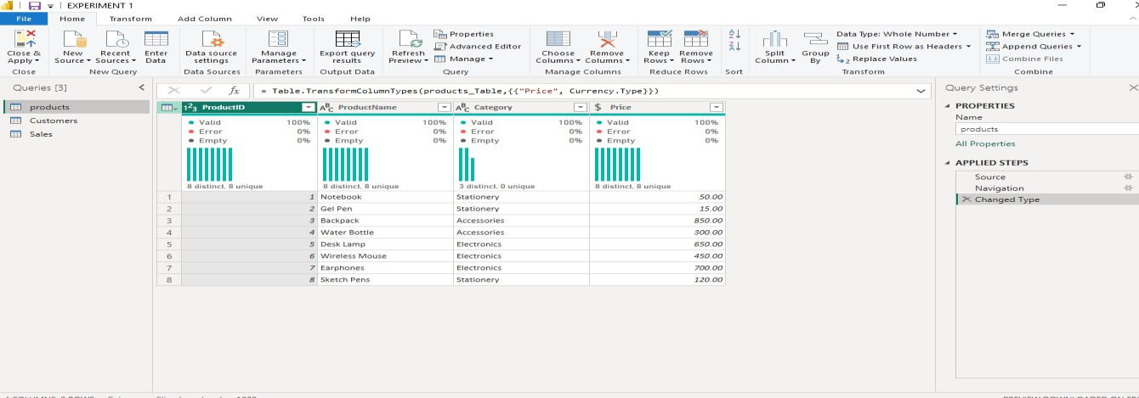

Customer Data :
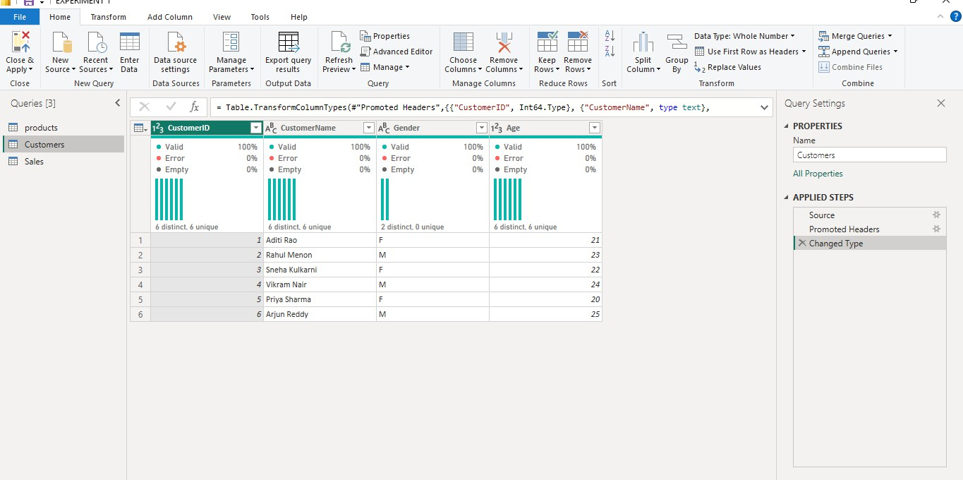

Sales Data :
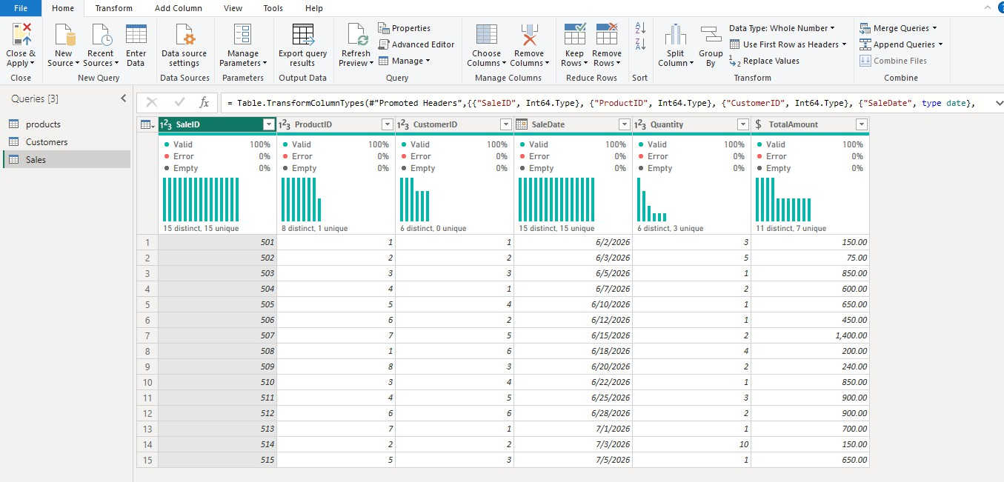

Step 2: Product Data Management Using MySQL

- Set up MySQL Server and MySQL Workbench on the system to host the product data.
- Created a new database called RetailDB to hold all retail-related tables

- Built a Products table with ProductID as the primary key, along with columns for ProductName, Category, and Price.

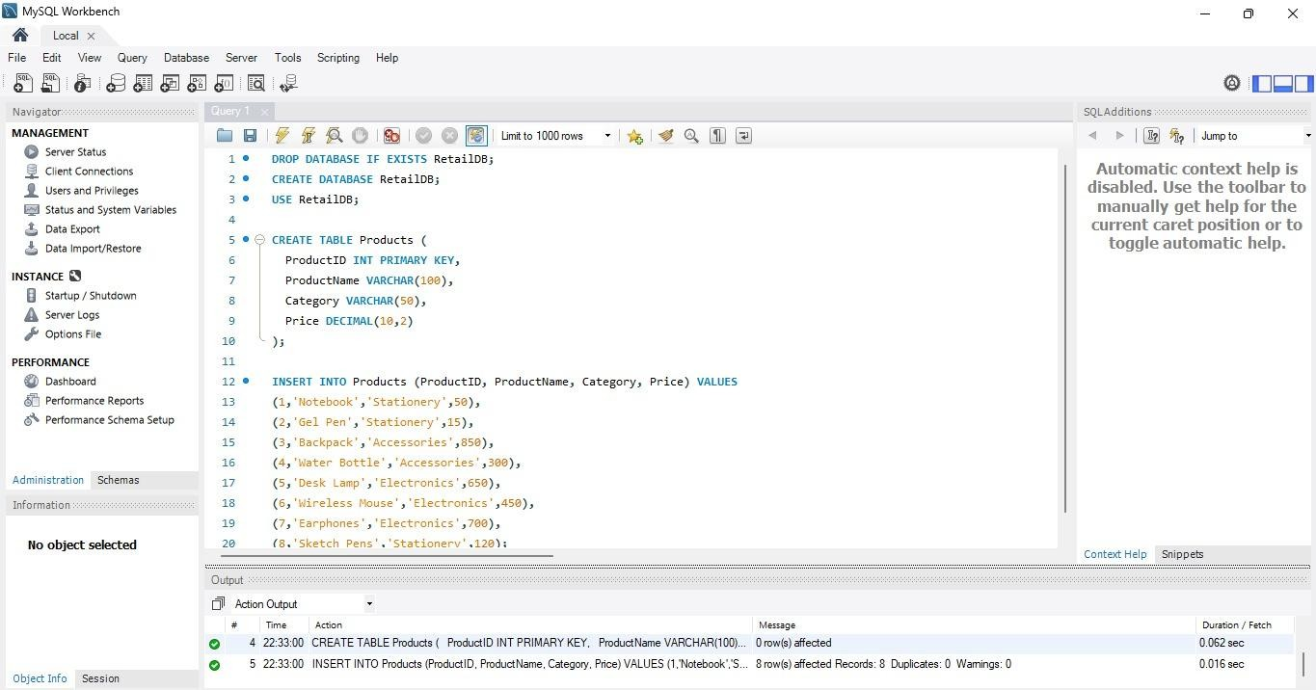

- Populated the table with product records and confirmed everything ran cleanly by
checking the Workbench output log all rows inserted, no duplicate entries, no warnings flagged.
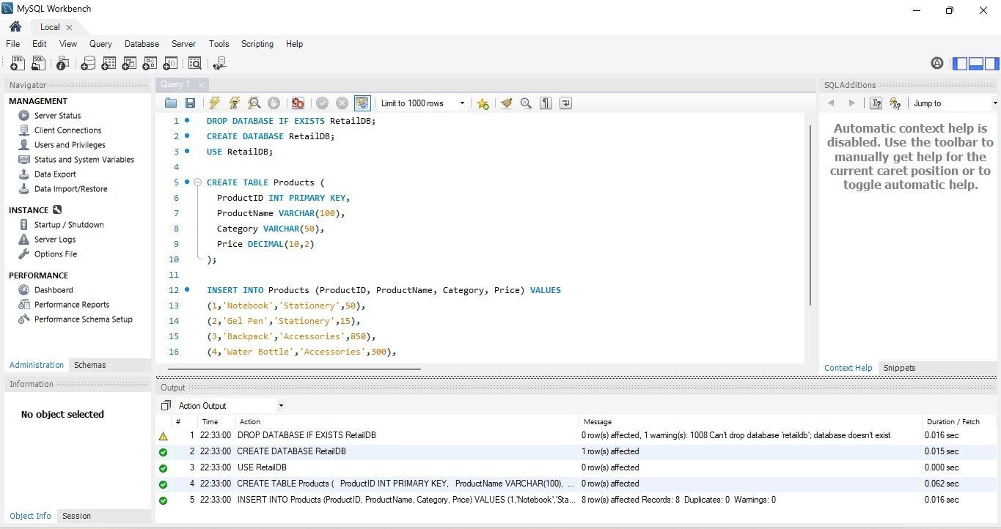

Step 3: Data Import into Power BI

- Launched Power BI Desktop to begin bringing all datasets together.
- Used Get Data → Text/CSV to load the Sales and Customer files directly, since these were maintained as flat files.
- Connected Power BI to the MySQL database to retrieve the Products table, linking it through the MySQL server where RetailDB was hosted.
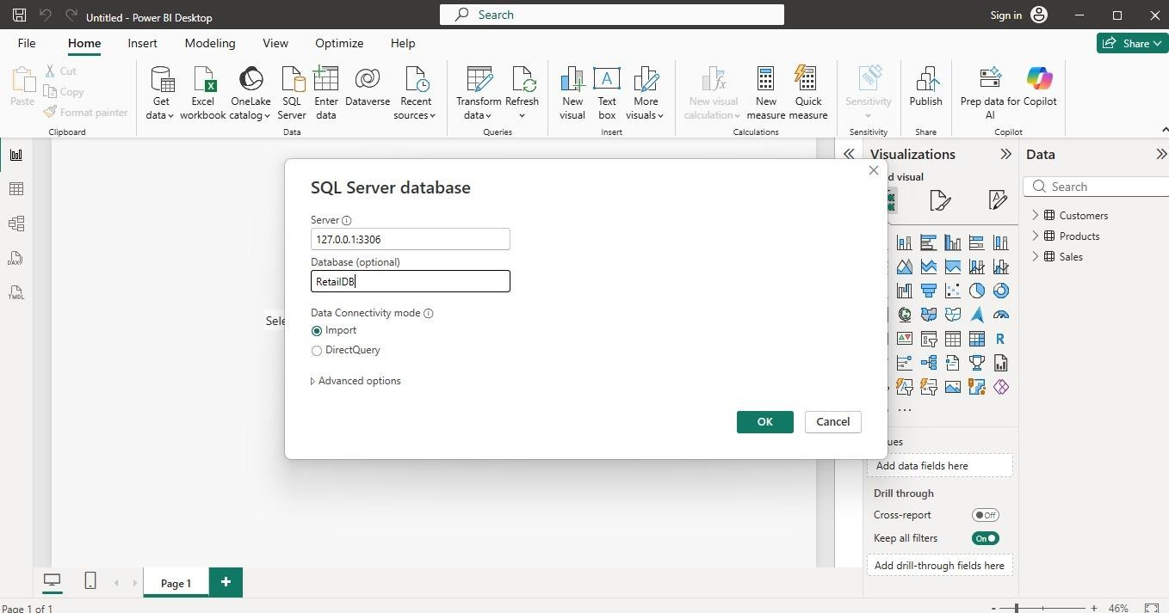

- Loaded all three tables Products, Sales, and Customers into Power BI so they were ready for cleaning and modeling.
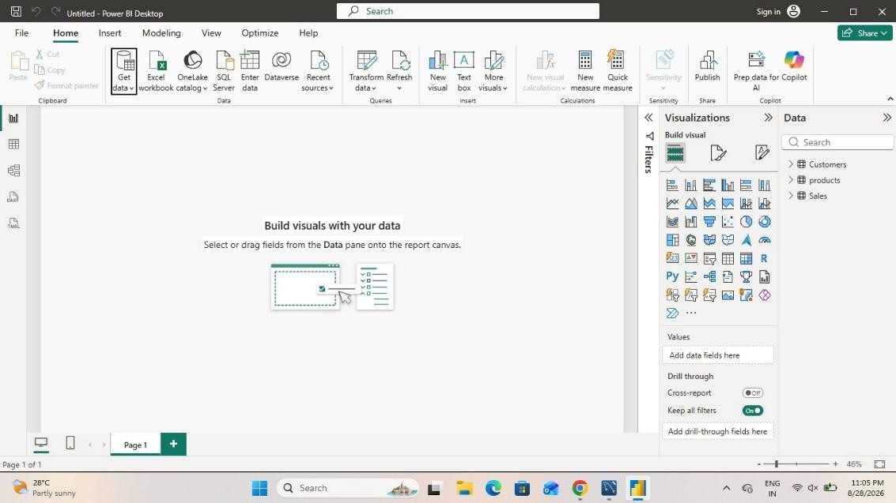

Step 4: Data Cleaning and Transformation

- Opened all three tables inside Power Query Editor for review.
- Scanned each dataset for missing entries and duplicate rows.
- Corrected column data types where needed: SaleDate set to Date, TotalAmount and Price set to Decimal Number, and Quantity and Age set to Whole Number.
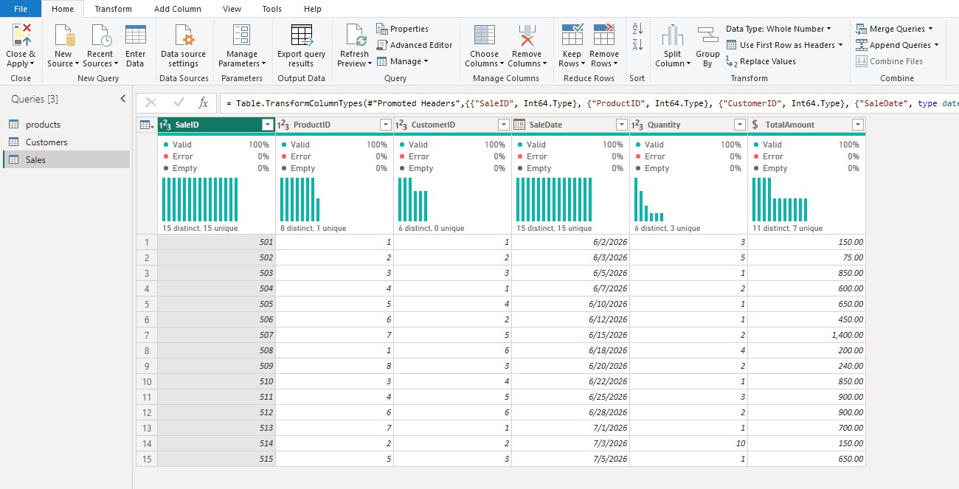

- Reviewed column names across tables to keep them clear and consistent for reporting.
- Made sure key fields like ProductID and CustomerID were properly formatted so relationships could be built without errors.

Step 5: Data Modeling

- Switched over to Model view in Power BI to connect the tables together.
- Built Relationship 1: Sales linked to Products through ProductID allowing sales figures to be broken down by product and category.
- Built Relationship 2: Sales linked to Customers through CustomerID allowing sales figures to be broken down by customer demographics.
- Both relationships came out as one-to-many, with Sales acting as the fact table and Products/Customers acting as dimension tables on the "one" side.
- The overall structure formed a simple star schema, which keeps aggregations accurate and avoids circular reference issues.

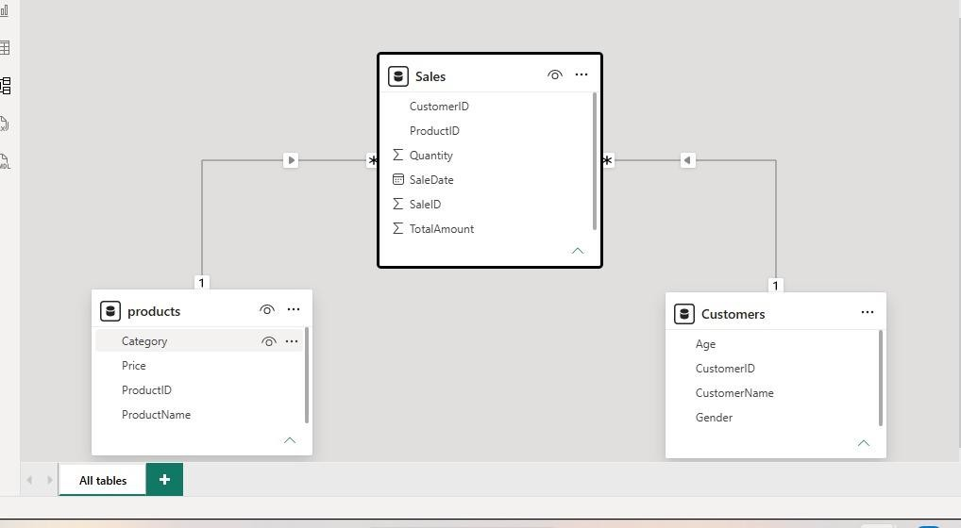

Step 6: DAX Measures

After the relationships were validated, DAX measures were created to translate raw transaction data into meaningful business metrics. These measures were added to the Sales table since it acts as the fact table for the model.

Total Sales = SUM(Sales[TotalAmount])
Adds up the TotalAmount column across all transactions to give the overall revenue figure.

Total Orders = COUNT(Sales[SaleID])
Counts the number of sale records to represent the total number of orders placed.

Total Quantity = SUM(Sales[Quantity])
Sums the Quantity column to show the total number of units sold.

Total Customers = DISTINCTCOUNT(Customers[CustomerID])
Counts unique customer IDs to determine how many distinct customers made purchases.

Average Order Value = DIVIDE([Total Sales],[Total Orders])
Divides Total Sales by Total Orders to calculate the average value of a single order, using DIVIDE to safely handle any case where Total Orders might be zero.

Together, these five measures formed the foundation for the KPI cards and charts built in the next step.

Step 7: Dashboard Development

Built a Retail Business Performance Dashboard in Power BI, made up of:
- A Total Sales KPI card
- A Total Orders KPI card
- A Total Customers KPI card
- A Total Quantity KPI card
- A line chart tracking Total Sales across Sale Date
- A bar chart breaking down Total Sales by Product Category

Step 8: Interactive Filters and Slicers

To let users explore the data on their own terms, slicers were added to the dashboard for:

- Category
- Gender

These slicers give viewers the ability to narrow down the dashboard's visuals for instance,
isolating sales for a single product category, or comparing performance across genders without needing to alter the underlying report.

Step 9: Dashboard Formatting

- Titled the report page "Retail Business Performance Dashboard" to clearly convey its purpose.
- Positioned the four KPI cards in a row at the top for quick, at-a-glance metrics.
- Placed the line chart and bar chart below the KPI cards, with slicers arranged alongside for easy access.
- Applied a single consistent accent color across all visuals to keep the dashboard visually cohesive.
- Adjusted font sizes on chart titles and KPI values to improve readability.
- Added a small custom logo icon next to the dashboard title to give the report a more finished, branded look.

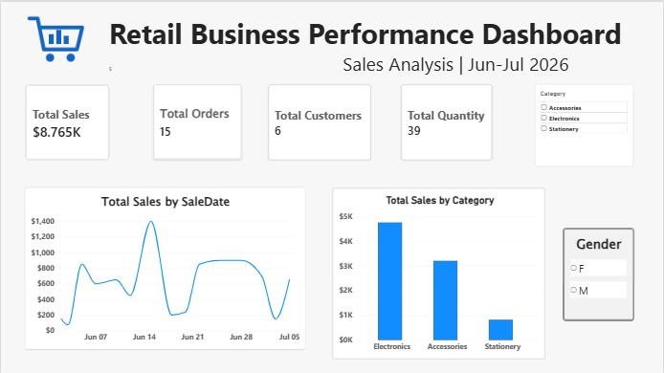

Step 10: Analysis and Insights

Using the completed dashboard, the following observations could be drawn:
- Overall revenue generated across the tracked period, visible directly through the Total Sales KPI.
- The total number of orders placed and the number of distinct customers who made purchases.
- The total volume of products sold, giving a sense of scale beyond just revenue.
- How sales fluctuated over time, based on the trend line across sale dates.
- Which product categories brought in the most revenue compared to others.
- How sales patterns shifted when filtered by category or by customer gender, using the interactive slicers.

Conclusion

This project brought together retail data from two different kinds of sources a MySQL-hosted product table and flat-file records for sales and customers into a single, unified Power BI report. The datasets were cleaned, standardized, and connected through a straightforward star-schema model, which kept the analysis accurate and free of relationship errors. DAX measures were then layered on top to surface key performance indicators such as Total Sales, Total Orders, Total
Quantity, and Total Customers. From there, an interactive dashboard was built using KPI cards, a sales trend line, a category-wise breakdown, and slicers for filtering by category and gender. The

end result is a centralized view that makes it easy to track retail performance and supports faster, data-backed business decisions.

Learning Outcomes

Through this project, I gained hands-on experience in:
- Data Collection and Integration - working with data spread across different formats, including flat files and a MySQL database.
- MySQL Database Management - designing a table structure, inserting records, and verifying data integrity using MySQL Workbench.
- Power BI Data Import - connecting Power BI to multiple types of data sources and loading them into a single report.
- Data Cleaning and Transformation - using Power Query to catch missing values, remove duplicates, and correct column data types.
- Data Modeling - building one-to-many relationships between a fact table and dimension tables using shared key columns.
- DAX - writing measures to calculate meaningful business KPIs from raw transactional data.
- Data Visualization - designing KPI cards, line charts, and bar charts to communicate business performance clearly.
- Interactive Dashboard Development - using slicers to give report viewers control over how they filter and explore the data.
- Practical Troubleshooting - working through real connectivity issues between Power BI and a database server, and finding an alternative way to complete the task.
- Business Analysis - interpreting dashboard outputs to identify trends and draw conclusions about overall business performance.

